Movie Maker
How to Import Video
First create a folder in your user area (My Documents) and name it ‘video editing.
Copy and Paste the unedited video footage that you have already taken into this new folder.

Begin by opening Movie Maker from the Start Menu.
From the task pane on the left under number 1 choose import video.
Browse to your new folder and select the video clip you just copied.

- Choose Import Video from the File menu or from the Task Pane.
- Browse to the Video Clip and click Import

Now save the project with sensible name in the folder you created.
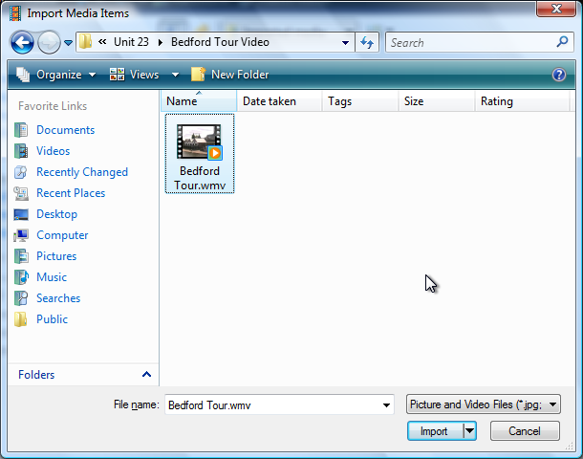
How to Add Clips to the Timeline/Storyboard
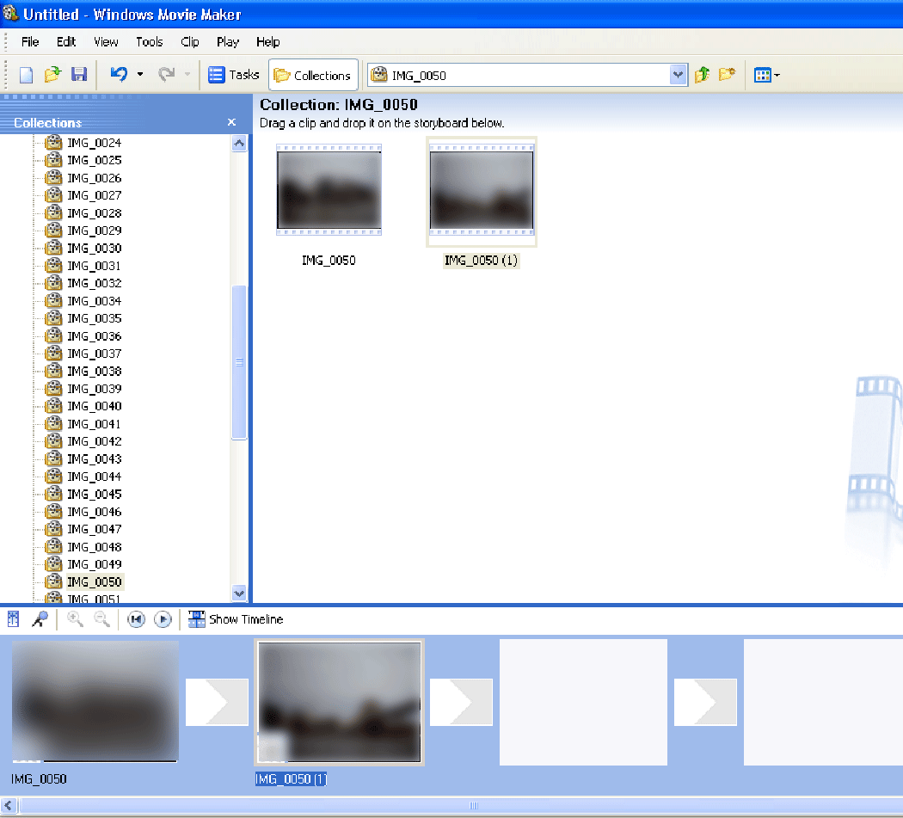
Choose the storyboard view from the View Menu or from the bottom of the window.

Drag the clips from the window to the larger slots on the storyboard at the bottom.

You may want to leave some clips out if they are too long or pointless.

How to Split a Clip
Once all of the clips you want to use are on the timeline you will need to split some clips in order to delete some of the clip that may be too long or may jump from one scene to another. To split a clip change to Timeline View and place the play head at the point you want to split the clip.
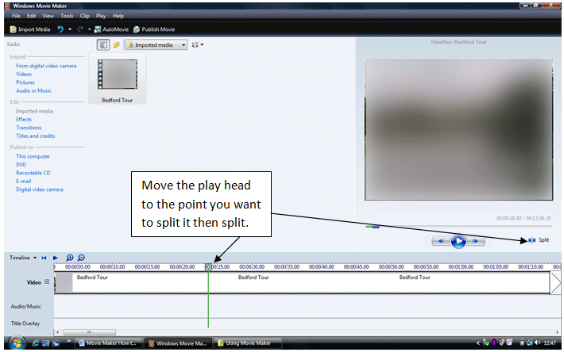
Move the play head to the point you want to split it then split.
How to Trim a Clip
To make a clip shorter move the mouse pointer over the end of the clip until it turns into a red arrow and drag. Let go once the clip is shortened to where you want it. Use the zoom if it helps.
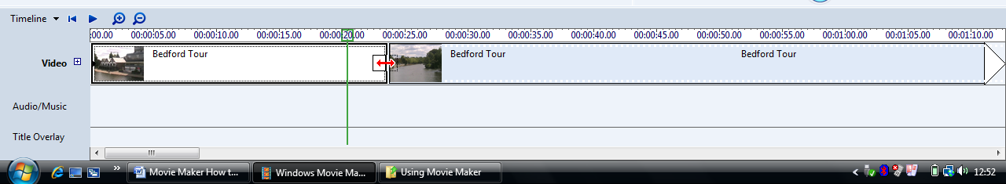

How to Add Transitions
Transitions allow a change from one scene to the next without a jump. It gives a smooth change from one thing to the next.
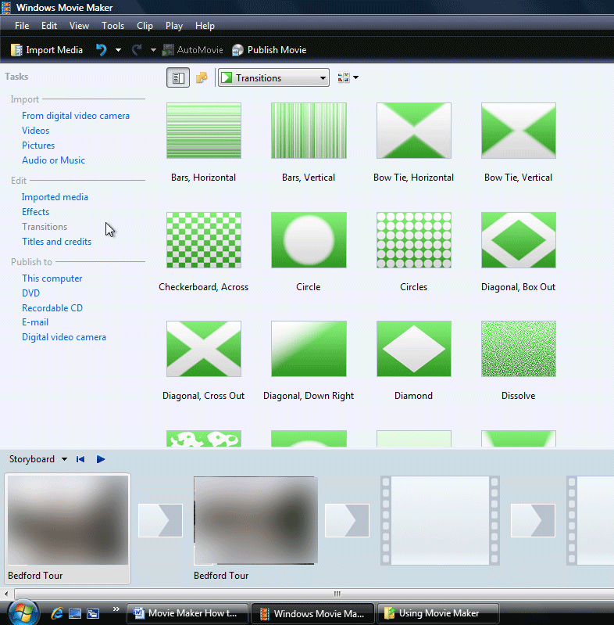
Choose Transitions from the Task Pane under 2 on the left. In Storyboard mode drag a transition from the collection onto the smaller boxes on the bottom between the clips. Don’t go mad and choose sensible transitions only where they are needed i.e. where there is a scene change.

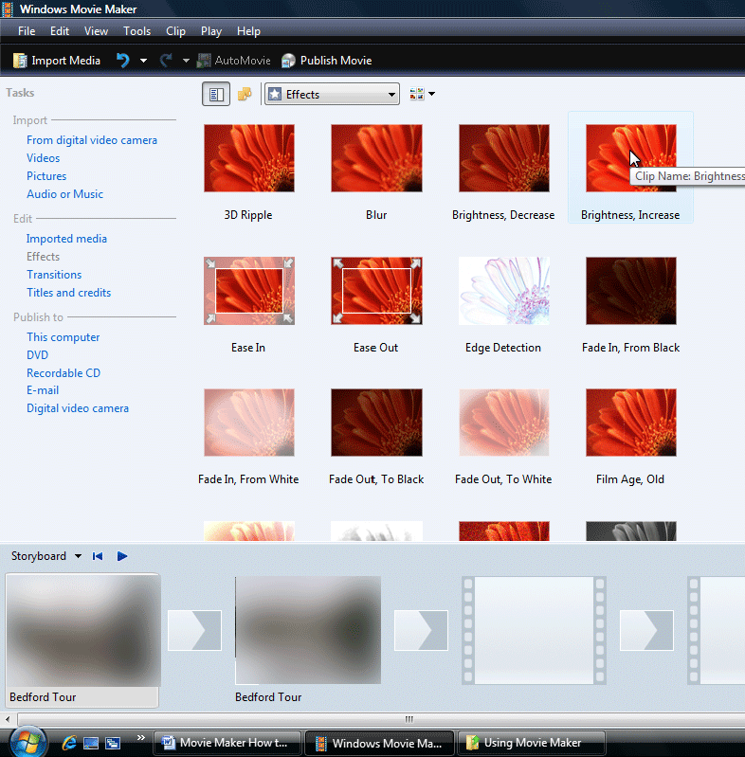
How to Add Video Effects
Video Effects allow you to slow down, brighten or add a special effect onto a clip. Not all effects are useful or appropriate but at least one must be applied to one clip.
Choose Effects from the Task Pane on the left and drag an effect onto a clip.

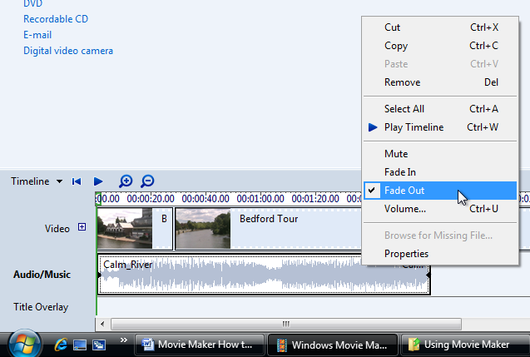
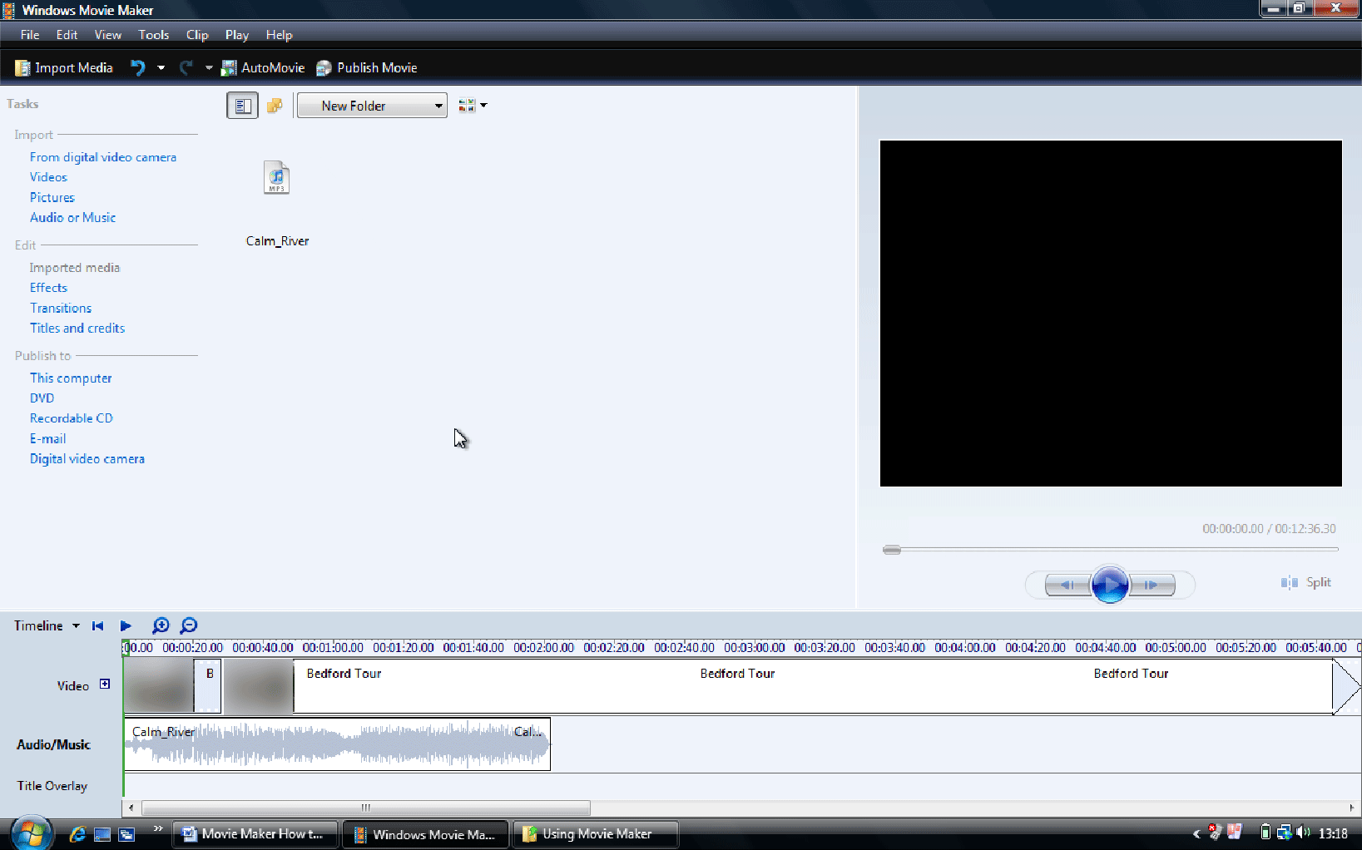How to Import a Soundtrack, Add a Soundtrack, Fade out a Soundtrack
Adding a soundtrack enhances the video and makes for a better atmosphere for your viewers. To import an mp3, wav or wma file choose Import Audio from the task pane on the left and browse for the file to use.

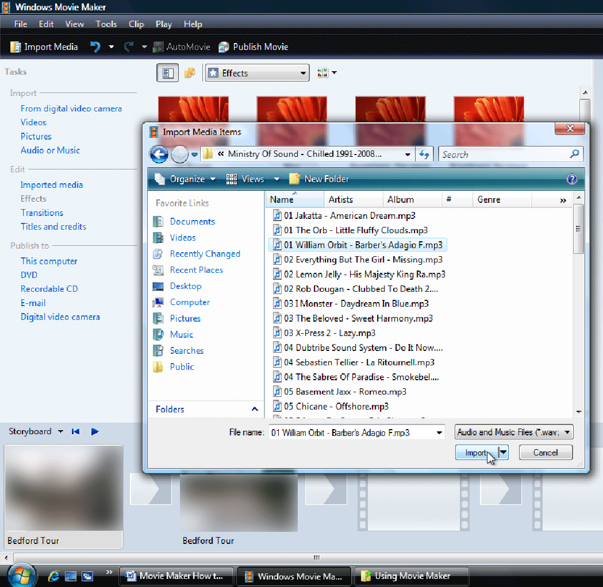Change to the Timeline View and drag the audio file to the Audio section of the timeline. Trimming and splitting is the same as with a Video Clip. If the music is not long enough add another file and trim it to fit the length of the clip. Fade out the music at the end.

Select the Audio then choose Clip from the menu and Fade Out. Alternatively right click on the Audio clip and choose Fade Out.
How to Add Titles and Credits
No film is complete without a title and the credits that run at the end. Choose Titles and Credits from the Task Pane on the left. Choose Title at the beginning. Give your clip a title and choose an animation and font, etc. from the links.
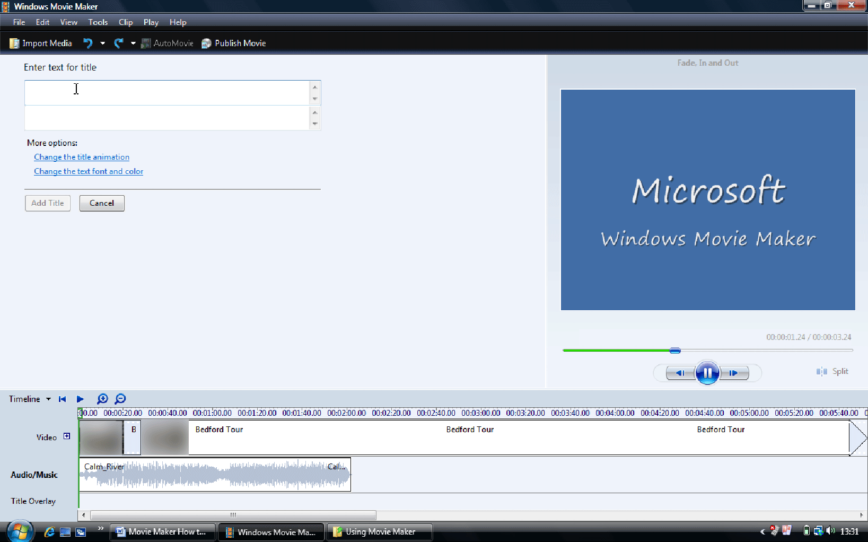

Repeat the process to add Credits at the end. Name yourself as producer, director, writer, etc.
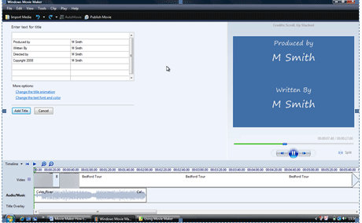
How to Export the Project
Once the project is complete and contains all of the elements required it needs saving as a movie. Make sure you save the project one more time before exporting.
From the File Menu choose Make Movie. From the options choose to save a file for playback on the computer. On the next screen browse to the folder you created and give the finished movie a name. On the next screen make no changes and wait until the video is complete. Finally you will get the option to watch the video in Windows Media Player.
How to Watch the Finished Video Clip
Go to your folder to find the completed movie. Double click to play.

