- Open a new Excel spreadsheet
- Save this as Sum and Average in your ICT folder
- Type in the following text
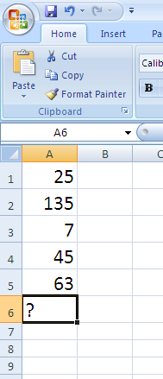
- Click in A6 where the total will appear and type the following function
=sum(A1:A5)
A total should appear in A6 (275)
- Practice this using the samples below
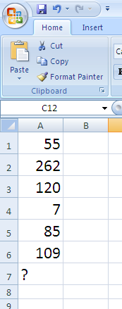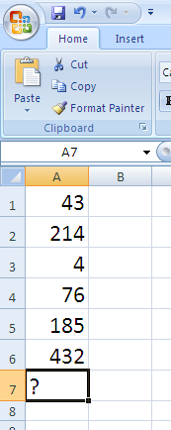
- Do the same with the below numbers but in cell A7 type in =Average(A1:A5)
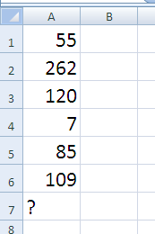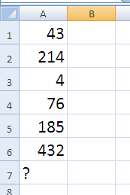
- You could also use MAX and MIN these will find the highest and lowest figure

