- Open a new Excel spreadsheet
- Save this as Springdale Sports Centre in your ICT folder
- Type Springdale Sports Centre in A1, Centre the main heading over cells A1 – D1 by highlighting the cells and then clicking ‘merge and centre’
- Type in the following text

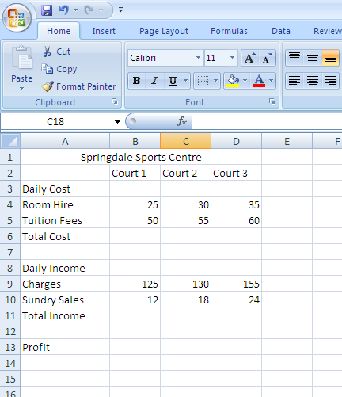
- Make the heading bold, and font size 16
- Courts 1,2 and 3 centre the font and make size 12
- Daily costs and Daily income centre and size 12
- Format the numbers to currency and 0 decimal places
- Using a suitable formula put the total costs into cell B6 (hint B4+B5), copy that formula to C6 and D6
- Do the same to fill B12, then copy it to C12 and D12
- Now calculate the profit in B13, C13 and D13 (hint B12-B6)
- Insert a header
- Save, print and close

