- Open a new Excel spreadsheet
- Save this as Sales in your Functional skills ICT folder
- Type in the following text
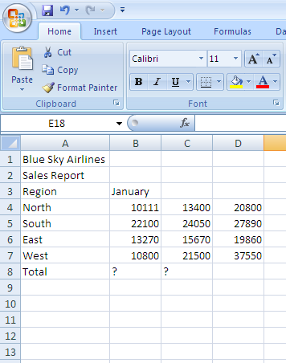
- Save
- Make A1 Bold and Size 14
- Make A2 Bold
- Increase row height
  - Select row heading 1 to 8
  - Right click on the mouse
  - Select row height and insert 20, then click OK
- Enter Heading and Autofill
- Select B3, point to the bottom right hand corner until you get the cross, click and drag to D3, this will fill in the other months.
- Insert a function into B8 that gives you a sum of the entries, copy this across to C8 and D8
- Format the cells to make the spreadsheet look good

- Create a Pie Chart
  - Select A4 to A7
  - While this is selected, hold CTRL and select D4 to D7
  - Then click on Insert and then Pie –
- Save, Print and close

