- Open a new Excel spreadsheet
- Save this as Computer in your ICT folder
- Type in the following text
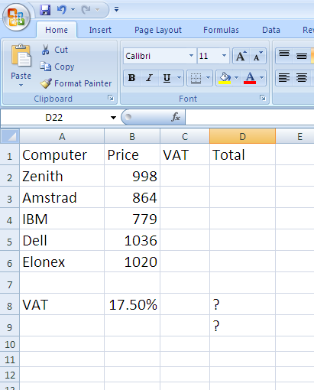

- Centre and bold the headings.
- Format the cells from B2 to D6 to currency to 2 decimal places.
- Insert the formula using an absolute cell reference in cell C2 and copy this down to C6.
- Insert a formula in D2 adding the price and the VAT together and copy this down.
- In cell D8 enter a function that will sum up the total costs.
- In cell D9 enter a function that will find the average costs.
- Use any other method to make the spreadsheet presentable.
- Create any chart to show the computers and the total price.
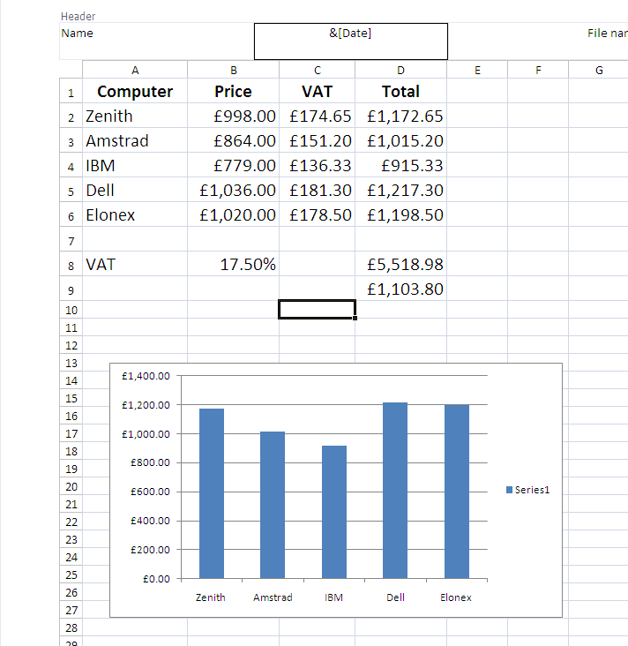
- Insert a header.
- Print your spreadsheet.
- Save and close.

