EXCEL EXERCISE

Objective Learning to use the =Index Function in Excel

ST 1: Load up Microsoft Excel and rename the pages

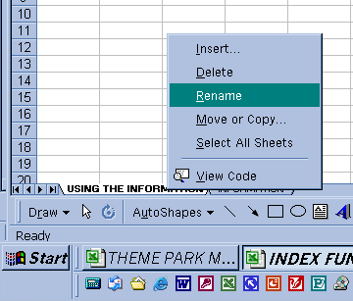
Name one ‘Using the Information’ and the other ‘Information’

ST 2: On the sheet entitled ‘Information’ enter the following table

Item Name | Buying Cost | Number in Stock | Selling Cost
Optical Mouse | £7.99 | 24 | £16.99
Keyboard | £5.99 | 25 | £19.10
Speakers | £12.99 | 36 | £17.99
Monitor | £34.77 | 12 | £89.09

Then add a further 6 items to the table

ST 3:Highlight the information and not the titles!! Then Click Insert-> Name -> Define
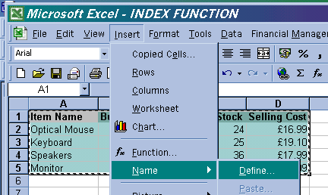
NEXT Name the information ‘Items’

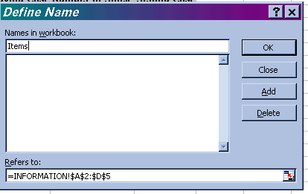

ST 4: Click View->Toolbars->forms

This will then turn on the Forms Toolbar
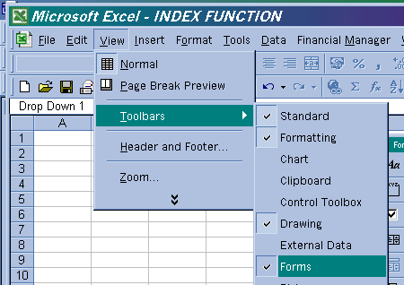

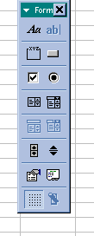

Then click on the ‘Combo Box’ Creator and then draw a combo box on the spreadsheet

Then Double Click the combo box

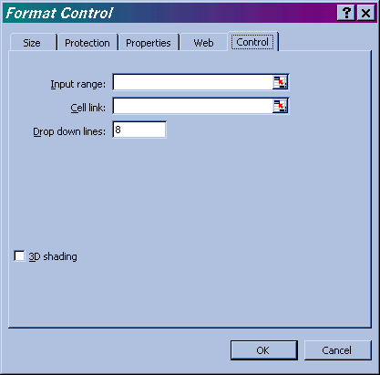
Click on the ‘Highlighter’ then select all the information expect for the Titles that you keyed into the ‘information’ sheet

Type in $c$4

Then Click OK

ST 5

Enter the following labels
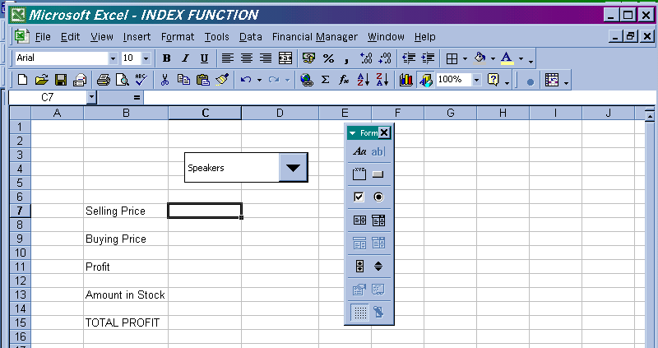

ST 6: Enter the formula in the cell next to ‘Selling Price’

=index(items,C4,4)

If you then change the item using the combo box it will change the value in this cell.

It works by Simply turning the information in the ‘information’ sheet into a big table. Then the formula =index lets us access it.
The name of the table
The number of rows to go across

=index(items,C4,4)
The number of lines to go down

For example if C4 = 2 then it would give you the number

Optical Mouse | £7.99 | 24 | £16.99
Keyboard | £5.99 | 25 | £19.10
Speakers | £12.99 | 36 | £17.99
Monitor | £34.77 | 12 | £89.09

As it is two rows down and four columns across!
Next complete the spreadsheet model so it will perform the following
- Work out the profit of each item
- Work out the total profit made if all the items in stock are sold
- The example MUST Change the answers if a different item is selected – you will need 3 = index formulas

You should end up with a spreadsheet similar to the one below
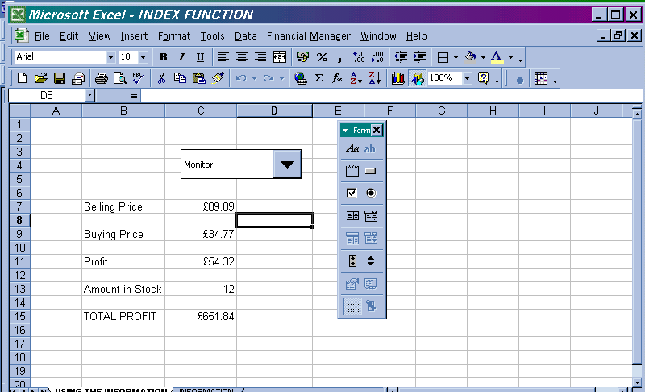

Finally format the spreadsheet to look more appealing and then save the file and print

