What if I want to add some more dialogue to my recording?
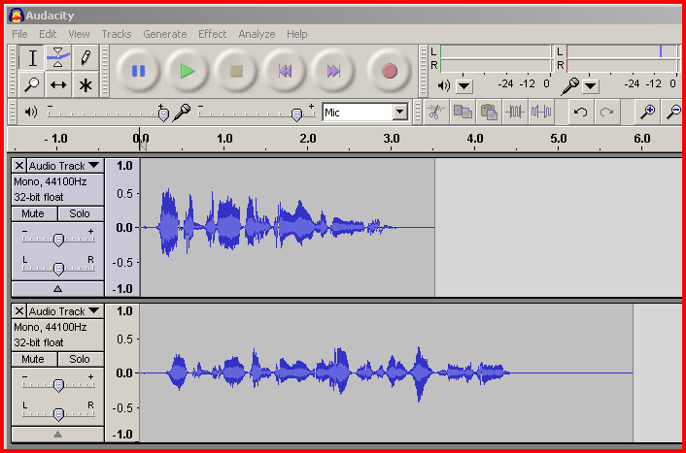
If you have made a recording, and after listening back, and you feel that you might have missed something out, simply click ‘record’ again. This will open a second Audio Track. Then talk through the section you want inserted, and select ‘stop’ when completed.

To place this newly recorded Audio Track into position desired within the recording use which is the ‘Time Shift’ tool found in the ‘Control’ toolbar.

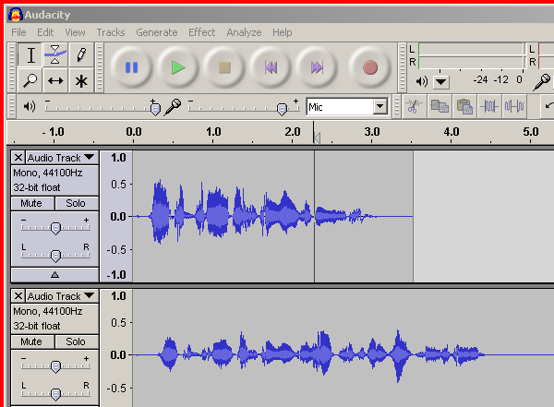
This is done using the following steps:

- Position the cursor line at the point with in the recording where the second recording will fit in, shown in fig 9.

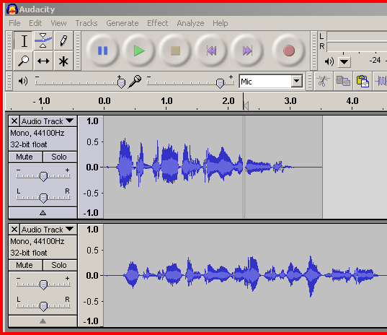
- Then go to the ‘Edit’ menu bar and select the ‘split’ option. This creates a small gap in the recording.

- Using the ‘Time Shift’ tool hold the cursor over the new audio track recording, click and hold down the left mouse button and move the recording to a position where the start of it id aligned with the split as shown in fig 11.
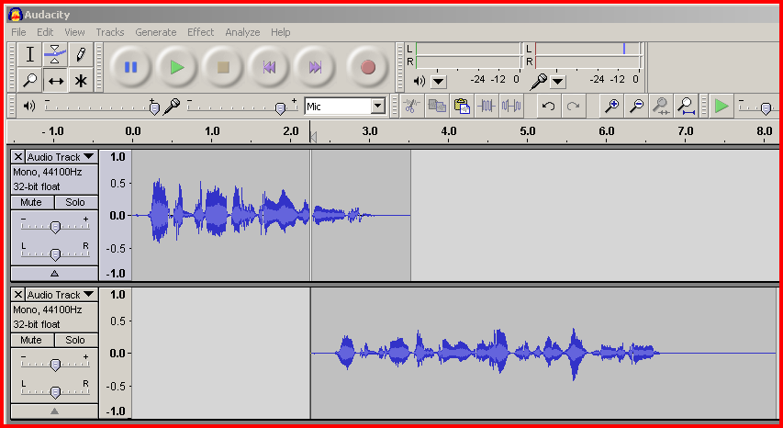

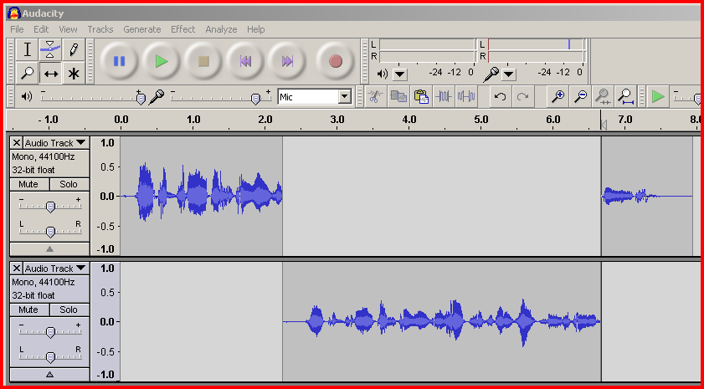
- Finally do the same with the sound wave to the right of the split in the first Audio Track. Using the ‘Time Shift’ tool, positioning it at the end of the recording in the second audio track. The recording will now play back seamlessly with the new recording section inserted.

Use the Envelope tool to adjust volume on tracks/parts of tracks
Select the Envelope tool

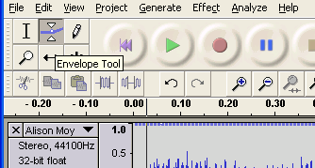
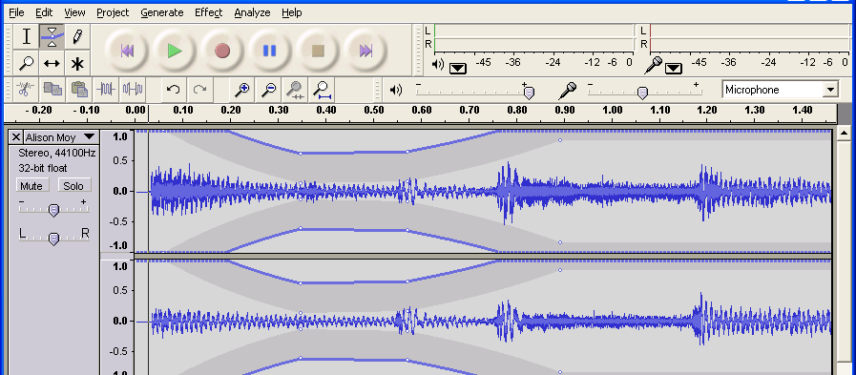
Point & click to insert edit points on to the envelope.
The points can then be dragged down to lower the volume between the points, to fade in or fade out sections. (Fade in & fade out also available in Effects menu)

Sounds can be modified by applying effects and filters

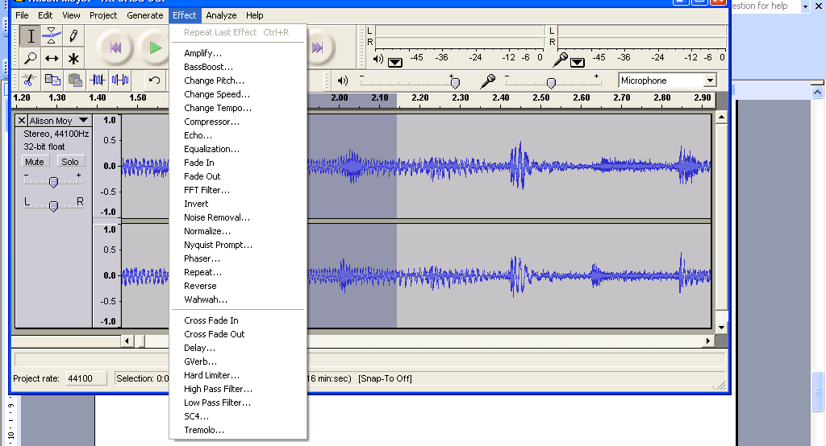

Try effects out on a copy of a good track until you understand what they do

Copy the track to work on it, mute the original.

Highlight the track (or part of track) you want to apply effects to

Highlight the section then apply the effect, always listen to the results.

Saving your recording in a suitable format to listen to anywhere.

- On the ‘File’ Menu select ‘Export as mp3’.

- This leads to a save window, which prompts you to name your recording and select where you would like to store it on your computer. Then select ‘ok’.

- The first time this process is carried out the message shown in fig 14 will appear. This is asking you to locate the lame_enc.dll file, select yes and then use the browser to find the file downloaded.
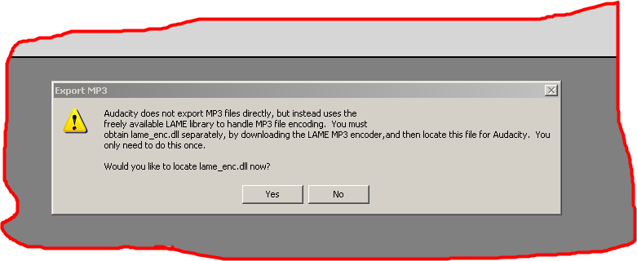

Fig 14

- Thankfully, this step of the process only has to be done once. After this, on using steps 1 and 2 (above), Audacity will convert your recordings to an MP3 format.

