Name……………………………………………………………..

Hacking

- What is a hacker?
Someone who breaks codes and passwords to gain unauthorised entry into a system

- What sort of computers are in the most danger of being hacked?:

- What are the two ways that data can be stolen?

1 | Physical theft of hardware
2 | Unauthorised access into system

- Label the possible effects of the theft of data shown below

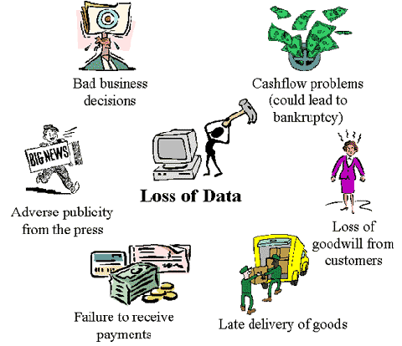
- What are the three main ways that businesses can protect data can be protected against hacking?
1
2

3

- Fill in the blanks below

1 | Keeping important __________________________ such as servers or  mainframes in _______________ rooms
2 | ________________ security guards
3 | Security _____________ ,_________________cards
4 | Keeping _________________data on ______________________  machines instead of ______________________
5 | Using _________________systems and _____________________
- What are the sentences above describing?

- Explain each of the words below

1 | Data encryption | data is 'scrambled' before being transmitted through a network. Only the authorised recipient has the 'key'. Find out a bit more about SSL (Secure Socket Layer) and https
2 | Firewall | software to block access from outside
3 | Levels of security | Different users are allowed different access rights

- Fill in the columns for Penalties

Illegal Act | Fine | Imprisonment
Unauthorised access to any program or data on a computer

Unauthorised modification of data on a computer
Computer fraud and blackmail

- What law makes the above acts illegal?

__________________________________________________________

5.

Write the type of license above the description | Who might have this sort of license?
Allows everyone to use the software. It can be loaded onto every machine and people can use it whenever they want.
Software can be used on one PC for as long as you like. But it is only allowed to be used on one PC at a time
allows a certain number of users e.g. 15 to use the software at any one time. When they log off the machine, another 15 can use it. However, if they allow the software to be used by 16 people at the same time then they are breaking the terms of the licence.

6. What penalties can you face if you are caught breaking the copyright laws?

- In the box below the scenario, write your opinion about it – is it right or wrong, what might happen next?

1 | John pays to join a web site where he can get essays and course work. He downloads some course work and passes it off as his own.
2 | Jane buys a cheap copy of a DVD at a car boot sale, she invites her friends round to watch it,

8. Go to the page http://news.bbc.co.uk/1/hi/magazine/3281977.stm

In the box below, write what you think are the three main points that the article is making.

The article is over a year old. Surf the web to see if you can find more recent articles about computer copyright in the UK.

