
Help, my computer won’t turn on .........

It is a horrible feeling when you press the power button on your computer and nothing happens. What should you do?

a. Panic, cry and then watch daytime TV

b. Run around like a headless chicken, muttering to yourself

c. Make your dad come home from work to fix it

d. Think, ‘brilliant, now I don’t need to do my English homework’

e. Work through the problem methodically and eliminate possible causes.

Hopefully after a bit of consideration, you answered (e).

You have decided that you are going to try to find out the cause of the problem. Have a look at the table below.

Step 1 | The first and most straightforward thing to check is whether the power is switched on at the wall – yes it might seem obvious but it is probably one of the most frequent causes of machines not switching on.
Step 2 | If the power is switched on at the wall, is the power switch turned on at the back of the computer?
Step 3 | If the switches are all on, is the power lead plugged securely into the back of the computer?
Step 4 | Is your monitor switched on and plugged in? The computer might be working fine, it might just be that you can’t see the output because of the monitor.

These are just a few of the things you can try, there are many more things to consider.

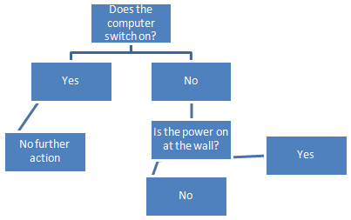
TASK 1
Undertake your own research on the internet and find out the main reasons why your computer won’t turn on or work.

TASK 2
Create a Decision Tree Diagram such as the one shown here.

Your aim is to give people a clear set of steps that they can work through if they experience this problem.

