
Create a Desktop Shortcut Icon

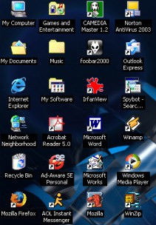

Shortcut icons on the desktop can be an excellent way of accessing applications and regularly used files quickly.

It is very easy to add a shortcut icon to your desktop

TASK 1
Using Windows Explorer go to your area and find a document, spreadsheet, presentation etc.

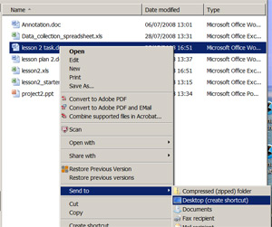
Do not open the file. Instead, right click on the name of the file. Choose ‘send to’ then choose ‘desktop (create shortcut).

A shortcut to this file should now be available on your desktop. Go and find it and then double click on the shortcut icon.

Did it open up the correct file?

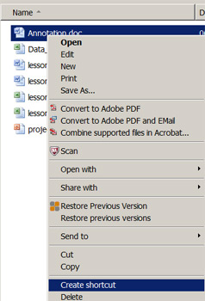
TASK 2
Find a different file to use this time. Again, don’t open the file.

This time, right click on the name and choose ‘create shortcut’. It should have created a shortcut to your document and placed it in the same folder rather than on your desktop.

You can now cut and paste this shortcut from the original folder and place it into a different folder or directory.

TASK 3
Rather than create a shortcut to a specific document, try to create one to a complete folder.

NOTE: This task might have to be completed at home if the network does not allow you to create shortcut icons on your desktop.

